Spiral 1 – Validation Layer Work
Project: UML to Code Generator
Member: Aayush Pathrabe
Role: Validation & Error Handling

Objective
The goal of my part in Spiral-1 was to add a validation layer on top of the parser output so that only correct UML models move to the next phase.
Parser gives extracted data → my module checks it → if valid it continues → if invalid it stops with proper error.

What I Received From Member 2
Parser output in the form:
Class → Attributes → Datatypes
My job was not parsing XML, my job was to verify that the extracted model is correct.

Work Done
1. Validation Module Creation
Created a Python validation module and integrated it with the parser pipeline.
Execution flow:
XMI → Parser → Validation → JSON Output

2. Validation Checks Implemented
✔ Empty class detection
✔ Duplicate attribute detection
✔ Empty attribute name detection
✔ Unknown datatype detection (bonus validation)
✔ Empty class name detection
If any of the above fails → execution stops with a clear error message.

Test Cases Performed
✅ Test Case 1 – Valid UML Model
Correct model with proper classes and attributes.
Output Screenshot:
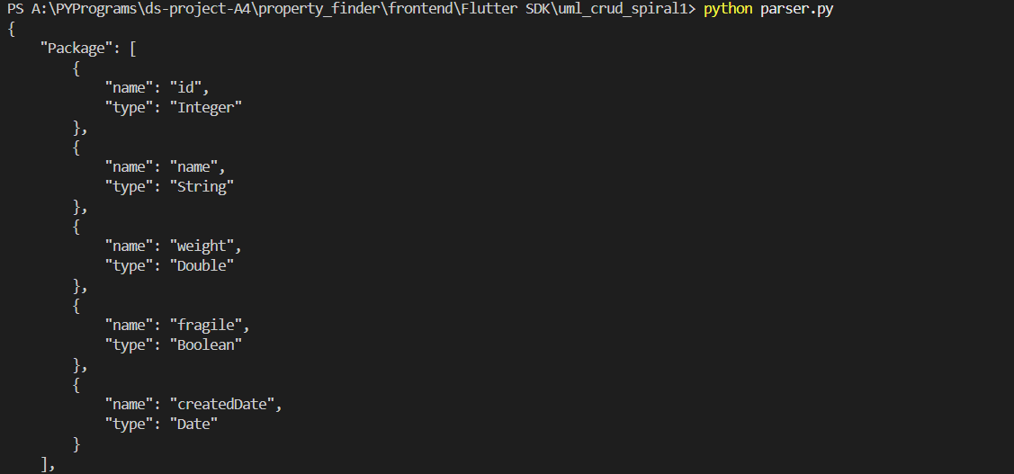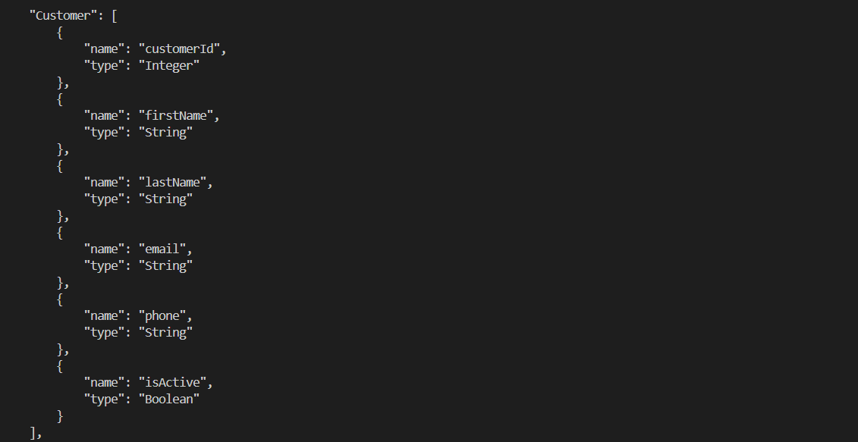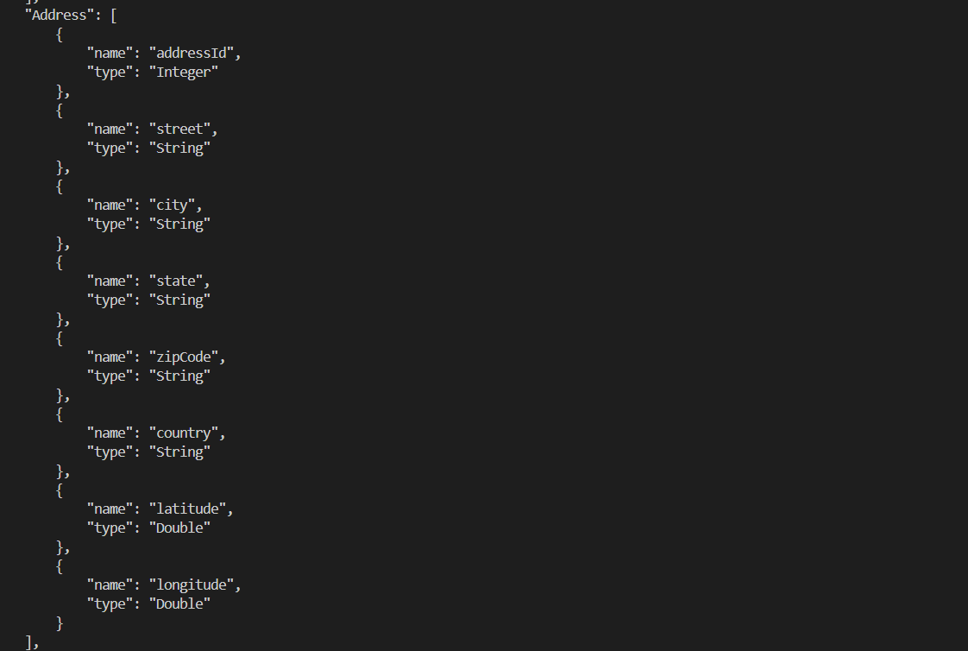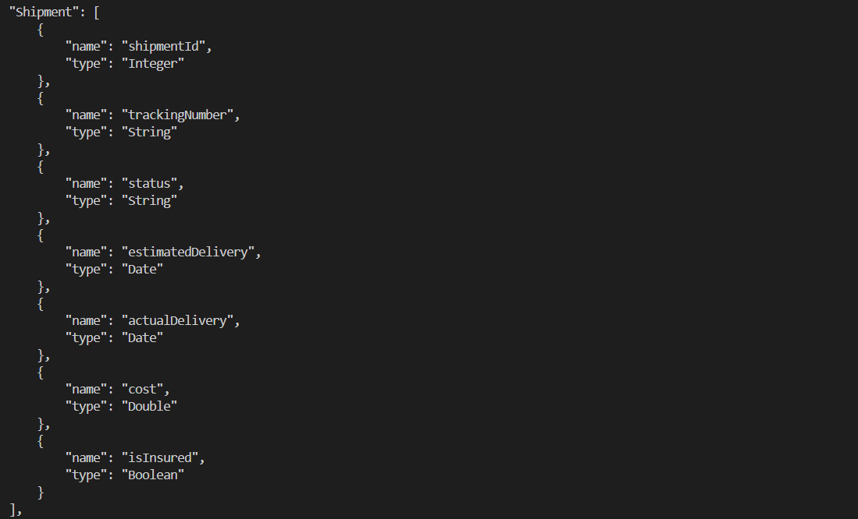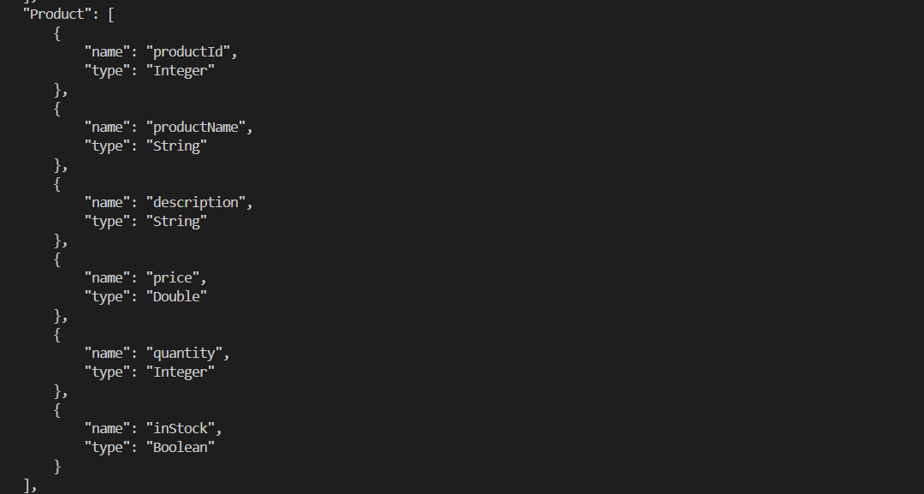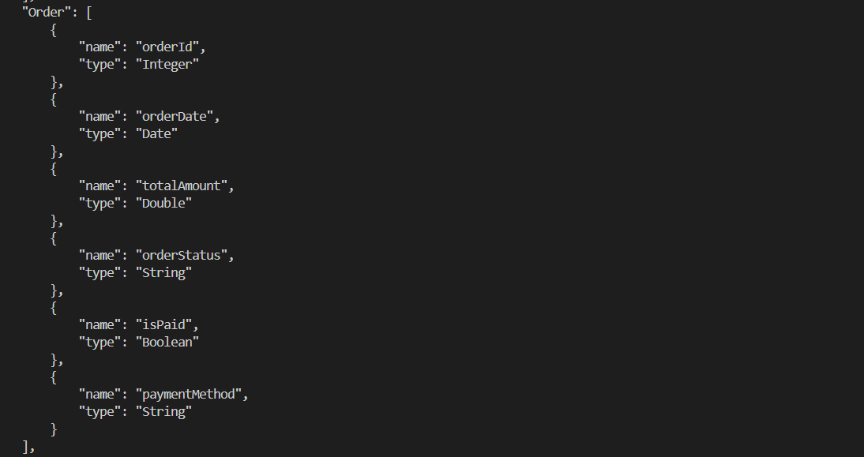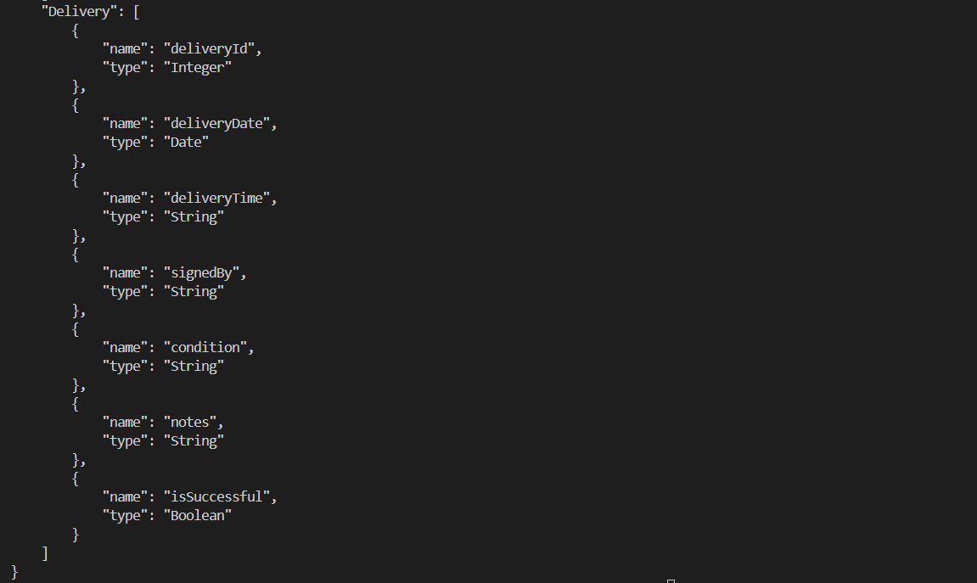

❌ Test Case 2 – Empty Class
A class without attributes.
Output Screenshot:

❌ Test Case 3 – Duplicate Attribute
Same attribute declared twice in a class.
Output Screenshot:

❌ Test Case 4 – Empty Attribute Name
Attribute with no name.
Output Screenshot:

❌ Test Case 5 – Unknown Datatype
Invalid datatype used for an attribute.
Output Screenshot:

❌ Additional Validation – Empty Model File
Output Screenshot:

Result
- Parser and validation successfully integrated
- Valid UML gives structured JSON
- Invalid UML stops execution with proper error
- System is now safe for next spiral

My Contribution to the Team
- Implemented validation layer
- Performed positive and negative testing
- Ensured data correctness before schema generation
- Improved reliability of the whole pipeline

Spiral-1 Status
✅ Validation Completed
✅ Integration Completed
✅ Testing Completed

